Connect AWS RDS through ADID (Windows)

Step 1 - Generate sso profile

aws configure sso --profile akashtilak@bajajfinserv.in

SSO session name = mail ID (username)
SSO start URL [None]= IAM identifier URL
SSO region [None] = AWS region
SSO registration scopes [sso:account:access] = ( hit enter)

copy the link https://device.sso.ap-south-1.amazonaws.com/ and paste in the browser and enter the code

Select account which you want to connect

CLI default client Region [ap-south-1] = AWS RDS region
CLI default output format [None] = (hit enter)

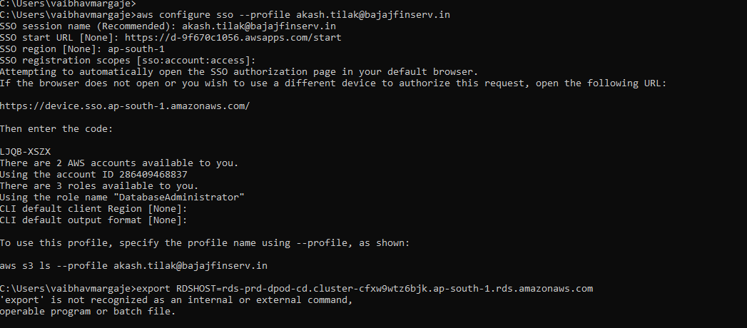

Step 2 – Generate Password

set RDSHOST=rds-prd-dpod-cd.cluster-cfxw9wtz6bjk.ap-south-1.rds.amazonaws.com

for /f "delims=" %i in ('aws rds generate-db-auth-token --hostname rds-prd-dpod-cd.cluster-cfxw9wtz6bjk.ap-south-1.rds.amazonaws.com --port 6434 --region ap-south-1 --username AROAUFL2VVOSY36VXXUJC:akashtilak@bajajfinserv.in ') do set PGPASSWORD=%i

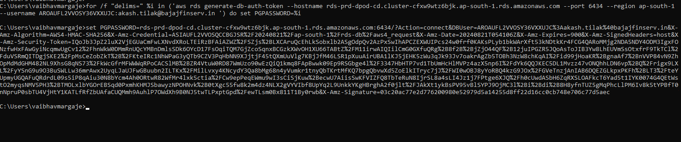

Step 3 – Login to Database

